The Secret Life of the Lengths of Littleneck Clams (mm) in Garrison Bay
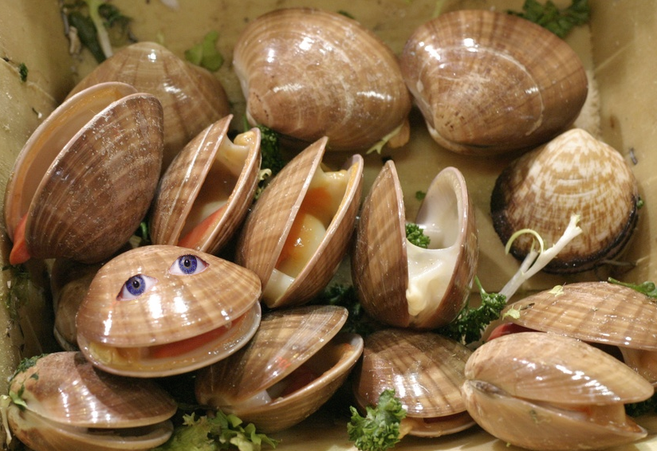
The littleneck clams had a strange mutation in their DNA, which lead them to grow significantly larger than any littleneck clams known to the world. This strange mutation is what has lead our scientist to study and take data samples on the clams in the area. There is a large possibility that the scientist gathered the right information for the wrong clam. When our scientist had brought in the data, we had to send our scientist out to actually retrieve a couple clams to bring back for further examination. It turns out the clams they had retrieved were actually Hippopus porcellanus, otherwise known as China Clams. This means that an invasive species has been introduced to Garrison Bay. The possibility of this event occurring is possible since we have had Chinese commercial ships come into Garrison Bay, Washington. Therefore, the clams could have come on the ships.
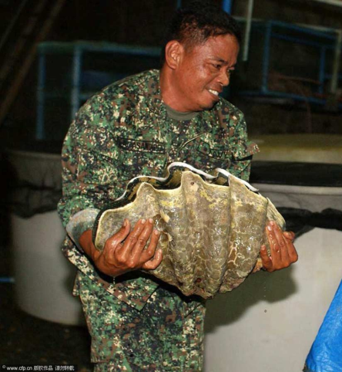

530 | 517 | 505 | 512 | 487 | 481 | 485 | 479 | 452 | 468
459 | 449 | 472 | 471 | 455 | 394 | 475 | 335 | 508 | 486
474 | 465 | 420 | 402 | 410 | 393 | 389 | 330 | 305 | 169
91 | 537 | 519 | 509 | 511

The sample size for the length of littleneck clams in millimeters in Garrison Bay is 35. The sample mean for the lengths of littleneck clams is 438.4 millimeters. The sample standard deviation is 96.38. The mean and standard deviation were found by running a 1-variable statistics on a calculator. The degrees of freedom for the lengths of littleneck clams in millimeters in Garrison Bay is 34. The degrees of freedom was found by taking the sample size of 35 and subtracting it by 1.
The critical value for a 90% confidence interval is 1.697. We found the critical value by taking the degrees of freedom (34) and confidence interval (90%), and then using a conversion table. The critical value for a 95% confidence interval is 2.042. We found the critical value by taking the degrees of freedom (34) and confidence interval (95%), and then using a conversion table. The critical value for a 99% confidence interval is 2.750. We found the critical value by taking the degrees of freedom (34) and confidence interval (99%), and then using a conversion table. All critical values were needed in order to find the maximum margin of error for the lengths of littleneck clams in millimeters in Garrison Bay.
The maximum margin of error for a 90% confidence interval is 27.65 millimeters. To find this, we used the formula E= t.c. (s/ √n). We then subbed in the values, which lead to the formula E= 1.697 (96.38/√35), leading to an answer of 27.65 millimeters. This means that a leeway of 27.65 millimeters is allowed to see what number of littleneck clams from Garrison Bay lies within 90% of$μ$. The maximum margin of error for a 95% confidence interval is 33.27 millimeters. To find this, we used the formula E= t.c. (s/ √n). We then subbed in the values, which lead to the formula E= 2.042 (96.38/√35), leading to an answer of 33.27 millimeters. This means that a leeway of 33.27 millimeters is allowed to see what number of littleneck clams from Garrison Bay lies within 95% of$μ$. The maximum margin of error for a 99% confidence interval is 44.8 millimeters. To find this, we used the formula E= t.c. (s/ √n). We then subbed in the values, which lead to the formula E= 2.750 (96.38/√35), leading to an answer of 44.8 millimeters. This means that a leeway of 44.8 millimeters is allowed to see what number of littleneck clams from Garrison Bay lies within 99% of$μ$.
The 90% confidence interval for $μ$ is 410.76 mm < $μ$ < 466.05 mm. To find this, we used the formula $▁X$- E < $μ$ < $\underline{▁X}$+ E. We then filled in the values, resulting in the formula 438.4 - 27.65 < $μ$ < 438.4 + 27.65. What this means is that there is a 90% chance that $μ$ is between 410.76 millimeters and 466.05 millimeters. The 95% confidence interval for $μ$ is 405.13 mm < $μ$ < 471.67 mm. To find this, we used the formula $▁X$- E < $μ$ < $\underline{▁X}$+ E. We then filled in the values, resulting in the formula 438.4 - 33.27 < $μ$ < 438.4 + 33.27. What this means is that there is a 95% chance that $μ$ is between 405.13 millimeters and 471.67 millimeters. The 99% confidence interval for $μ$ is 393.6 mm < $μ$ < 483.2 mm. To find this, we used the formula $\underline{▁X}$- E < $μ$ < $\underline{▁X}$+ E. We then filled in the values, resulting in the formula 438.4 - 44.8 < μ < 438.4 + 44.8. What this means is that there is a 99% chance that $μ$ is between 493.6 millimeters and 483.2 millimeters.
Had we been given$σ$, or the population standard deviation, we would have had to use a different formula. The formulas we would have used are E=z.c. ($σ$ /√n), $▁X$- E < $μ$ < $\underline{▁X}$+ E, and n = [(z.c. x $σ$)/E]^2, which would have given our data set of the lengths of littleneck clams in millimeters in Garrison Bay different results. Our data would be much more accurate due to having access to the entire population, and we could draw other conclusions from differences in growth be gender and age.

