Top College Football Players Based on Points Scored
By: Taylor and Olivia

Top College Football Players by Points Scored as of October 5

4 | 2 2 2 2 2 2 2 2 2 2 2 2 2 3 3 4 4 4 5 5 5 6 6 6 7 7 8 8 8 8 8 8 8 8 8 8 9 9
5 | 1 2 4 4 4 4 4 4 4 6 6
6 | 0 0

4 | 2
means 42 points scored by a college football player.

The stem-and-leaf plot ranks the order at which points were scored while arranging them into groups based on the tens place. Players were mostly in the 40s range. The 50s range was less than half of the 40s range, and the 60s range only had a total of two data points.

Top College Football Players by Points Scored as of October 5

Class Width: 3
Class Limits | Class Boundaries | Midpoint | Frequency | Relative Frequency | Cumulative Frequency
42-44 | 41.5-44.5 | 43 | 18 | .35 | 18
45-47 | 44.5-47.5 | 46 | 8 | .15 | 26
48-50 | 47.5-50.5 | 49 | 13 | .25 | 39
51-53 | 50.5-53.5 | 52 | 2 | .04 | 41
54-56 | 53.5-56.5 | 55 | 9 | .17 | 50
57-59 | 56.5-59.5 | 58 | 0 | 0 | 50
60-62 | 59.5-62.5 | 61 | 2 | .04 | 52

The frequency table displays the frequency of points being scored for a particular data range, while also showing the relative and cumulative frequency. Frequency is how many times an event occurs so, for example, in the 42-44 point range, 18 players were able to score in this range. The relative frequency is the portion out of one for how many times an event occurs so, for the same example, the relative frequency for the event would be .35. The cumulative frequency is a accumulation of all the data, which can be found by adding all of the frequencies together.

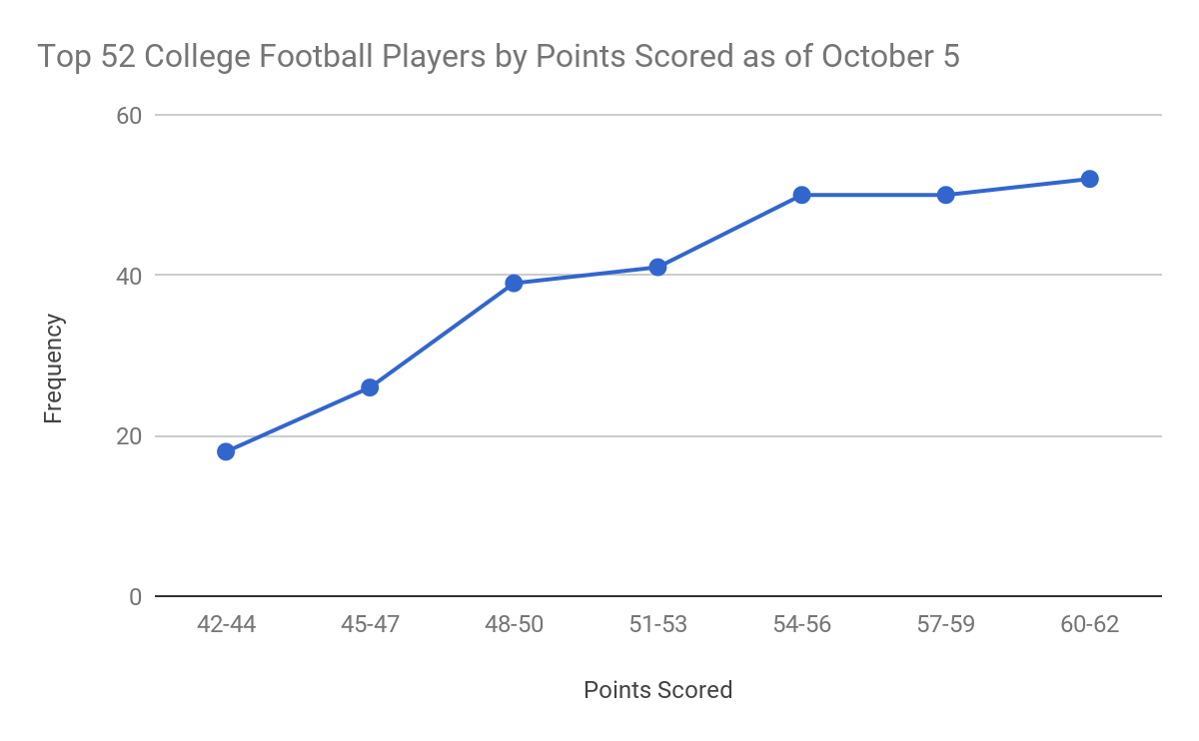
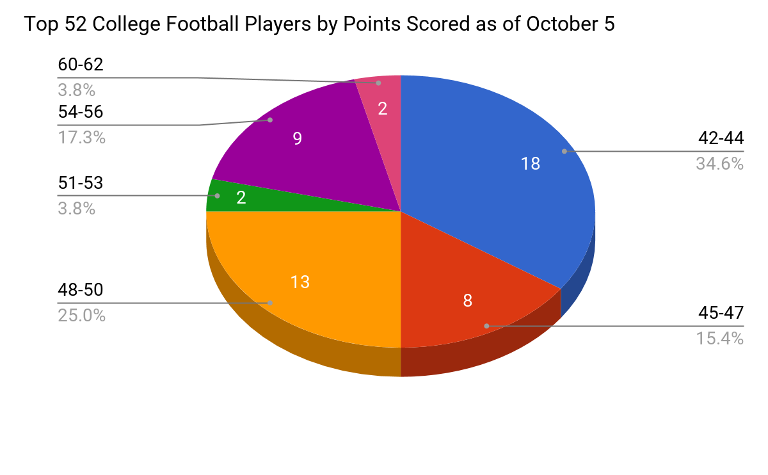
The circle graph displays proportional parts of each range compared to the whole set of data. Using this visual, it is easy to see what point range was the most common, what one was least common, and what ones fell in between.
The ogive is a representation of the cumulative frequency, which is the sum of the frequencies of a data set. It’s useful if a person wants to pinpoint exact frequencies while seeing how they increase. However, it can be misleading as it could be mistaken for a time-series graph.
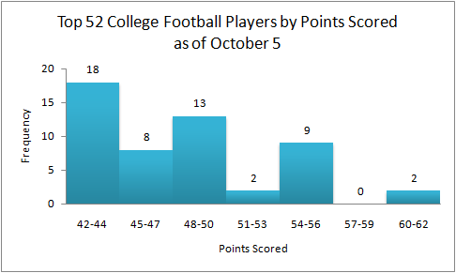
Histograms provide a way of displaying data found in frequency tables. It is easy to read due to the different peaks, and can help a person see trends in data. The histogram could be described as trimodal because it has three peaks that are each separated by one class, and they all have varying values.

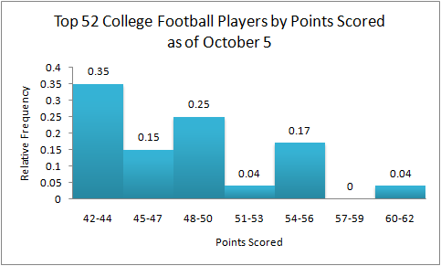
The relative frequency histogram is visually similar to a regular histogram. However, it gives decimals for the rate of frequency at which an event occurs. Therefore, the percentage rate for an occurrence can be determined. For example, the rate of 42-44 points occurring is 35%, 45-47 points is 15%, and so on.
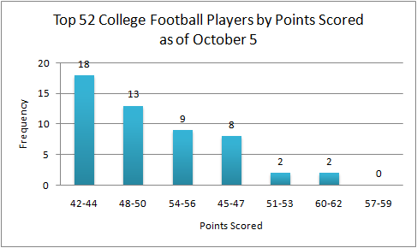
The most common frequency for points scored is in the 42-44 range. It is followed by 48-50, 54-56, 45-47, 51-53, and then 60-62. There was no player in the 57-59 range. The conclusion that can be drawn is that most players have scored fewer points, and when the range increases, there are fewer people that have or will fall in this range.

Although our research was originally going to be conducted using the top 50 football players by points scored, we had to change it to the top 52 players due to duplicate results. The website we used was http://www.espn.com/college-football/statistics/player/_/stat/scoring/sort/t
otalPoints/qualified/false. The highest number of points scored was 60, while the lowest number of points scored was 42. The most common number of points scored was in the 40s range, followed by the 50s range and the 60s range. This was expected because it’s still early on in the football season. Since our research was based on only one day, we were unable to make a time series graph because it didn’t change on October 5. However, it would be possible to make a time-series graph based on the stats of players throughout the entire season rather than looking at a point accumulation on one day.

