Statistics and Probability Chapter 3 Project: What is Your Shoe Size?
By: Taylor and Elizabeth

Our data set was on shoe size. We found that our most frequent shoe size was size 9 and our least frequent was size 13. We did a systematic sample of the students at Fowler High School. We chose every 10th student of different classes. Then, we went back and chose the 5th student of every class to reach a full set of 50 respondents. We asked about 13 people from the library the first day, then sent out a Google form through email to the rest of the students that had not responded yet. We only got about half of the student responses by day two, so we decided to just use the 26 responses to do our project and to not waste anymore time.

Shoe Size | Frequency
7 | 4
8 | 3
9 | 7
10 | 2
11 | 5
12 | 2
13 | 1
14 | 2
Greatest to Least
Shoe Size | Frequency
9 | 7
11 | 5
7 | 4
8 | 3
10 | 2
12 | 2
14 | 2
13 | 1
Total= | 26

The mean for shoe size of students surveyed was 9.81. The median and mode were both 9. The range was 7 because the largest shoe size was a 14 and the smallest shoe size was a 7. The 5% trimmed mean was 9.83, and the 10% trimmed mean was a 9.74, so both trimmed means were relatively close to the original mean. The standard deviation was 2.079. In order to find the variance, the standard deviation was squared, resulting in a variance of 4.322. The coefficient of variation was found by dividing the mean from the standard deviation and then multiplying the answer by 100, which was 21%. The 75% Chebyshev interval was 5.652 to 13.968. The 88.9% Chebyshev interval was 3.573 ro 13.383. The 93.8% Chebyshev interval was 1.494 to 18.126. The five number summary of the data was 7 (minimum), 8 (Q1), 9 (median), 11 (Q3), and 14 (maximum). The interquartile range was 3, so there were no outliers in the data set.

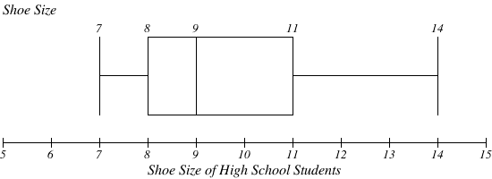
Our data analysis showed that the median shoe size for Fowler High School students was a size 9. However, this isn’t fully accurate not only because not everyone responded to our survey, but also because we only sampled part of the population of Fowler High School Students. For this reason, it wasn’t necessary to use population formulas involving sigma ($σ$) or mu ($μ$). If we had chosen to survey every student, there would be a potential for outliers and the five number summary would be different. WE think that if every student had responded to the survey, our data set would have been a more accurate representation of the average shoe size of students at Fowler High School.

