Movie Mania

0 | 0 0 0 1 1 1 1 1 2 2 2 2 2 2 2 3 3 3 3 3 4 4 4 4 4 5 5 5 5 5 5 5 6 6 6 7 7 7 8 9 9 9
1 | 0 0 1 3 5 8 9
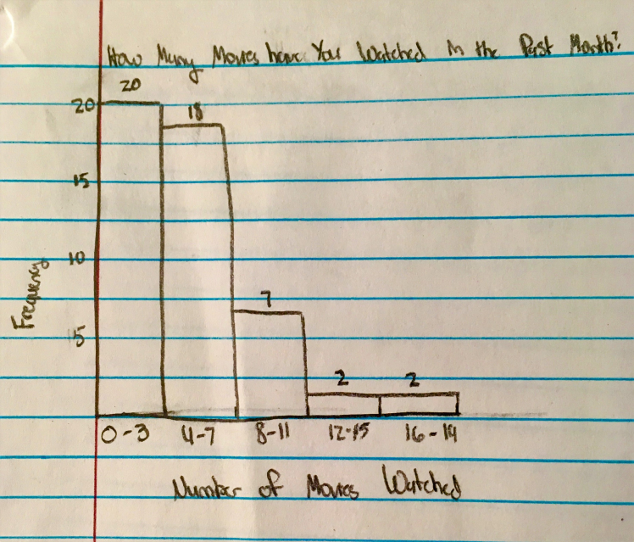
The mean for our data set of how many movies a person has viewed in the past month is 5.29 movies and the sample standard deviation for our data set is 4.39. The five number summary is found by going into stat, edit, then typing in all of the information we received after asking 50 people how many movies they have seen in the last month into L1. After typing all of the information in. go to calc, 1-var stats in the calculator and click enter and then enter again. Towards the bottom of this list is the five number summary. Our information for the summary is as follows:
The n value for our data set, which is the sample size, is 50.
The minimum for our data set is 0.
The Q1 value for our data set is 2.
The median for our data set is 4.
The Q3 value for our data set is 7.
The maximum for our data set is 19.
Our data does have a normal distribution. The histogram isn’t roughly bell-shaped. We calculated the skewness by using the formula 3(mean-median)/standard deviation. The formula then becomes 3(5.29/4)/4.39. The numerical value is 0.88, meaning our data isn’t skewed. Our data set also has an outlier. We had an outlier of 55, so we decided to get rid of the point so we would have a more accurate representation of our data. Therefore, we are able to abide by the normal distribution rules for our survey data. The empirical rule intervals for our data set are:
68% of our data falls between the intervals of 0.9 and 9.68, which means that 68% of people that were asked how many movies they had seen in the last month would answer between 0.9 movies and 9.68 movies.
95% of our data falls between the intervals of -3.49 and 14.07 which means that 95% of people that were asked how many movies they had seen in the last month would answer between -3.49 movies and 14.07 movies.

99.7% of our data falls between the intervals of -7.88 and 18.46 which means that 99.7% of people that were asked how many movies they had seen in the last month would answer between -7.88 movies and 18.46 movies.

Taylor has viewed 3 movies in the past month. The probability that a person would have chosen the same data point as her or one that is less than hers is calculated by taking the raw data value and subtracting it from the mean of 5.29. The answer is then divided by the standard deviation of 4.39. The answer is -0.52. By converting this number to a z-score, the answer is 0.3015, or 30.15%. The probability that a person would have an answer greater than 3 is 0.6985, or 69.85%, which can be found by subtracting 0.3015 from 1. Mariele has viewed 5 movies in the past month. The probability that a person would have chosen the same data point or less than her is calculated by taking the raw data value, which is 5 then subtract from that the mean, which is 5.29 then divide that answer by the standard deviation which is 4.39. The answer is -0.07. This answer converted to a Z score is 0.4721. This z score means that the probability someone would have an answer less than or equal to 5 is 47.21%. The probability that someone would have a value greater than 5 is calculated by subtracting 47.21 from 100 which is 52.79.

The probability that someone would have answered a number between Taylor’s and Mariele’s for the number of movies watched in the past month is calculated by finding the z-scores for 3 and 5, and then subtracting the smaller value from the larger value. The answer is .1706, or 17.06%.

The probability that a sample of 30 people would have an average greater than Taylor’s response to the question, “how many movies have you watched in the past month?” is 99.79%. To calculate this answer, take Taylor’s response which is the probability that a sample of 30 people would have an average greater than Mariele’s response, which is 5, is. To calculate this answer using the central limit theorem, take Mariele’s response, which was 5, subtract 5.29 which is the mean. After calculating that answer, take that answer and divide it by 4.39 which is the sample standard deviation and divide it by the whole population which is 30. That answer is 0.3594 or 35.94%. That is the probability that a sample of 30 people would have an average less than Mariele’s response. To find the probability that a sample of 30 people will have an average greater than Mariele’s response is subtract 35.94 from 100. The answer is 64.06%.

The raw data value below which only 3% of our data should fall for the number of movies a person has watched in the past month is -6.78. This can be found by finding 3% on the z-table, and then using the formula x= z$σ$ +$μ$. The formula with our data set becomes 0.3x4.39 +5.29, which gives us our final answer. What this means is less than 3% of people would have watched -6.78 movies in the past month. Although it is impossible to watch a negative number of movies, the calculation is a result of the varied data set. The raw data value above which only 3% of our data should fall for the number of movies a person has watched in the past month is 13.54. This can be found by finding 97% on the z-table, and then using the formula x= z$σ$ + $μ$. The formula with our data set becomes 0.97x4.39 +5.29, which gives us our final answer. This means that more than 97% of people would have viewed approximately 13.54 movies in the past month. This is possible due to it being a positive number, but the odds are still slim that this event would have occurred.

